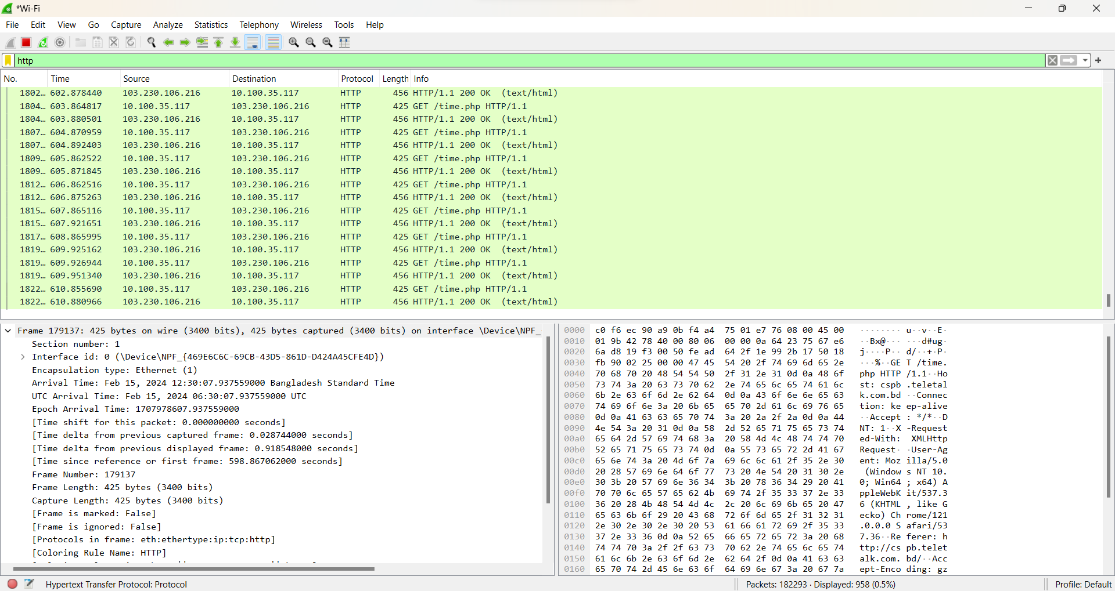

Frames are used in **Data link layer**. Frames are used in the OSI model to encapsulate data for transmission over the network medium, providing structure, control information, and error detection capabilities necessary for reliable communication between devices on the same network segment.

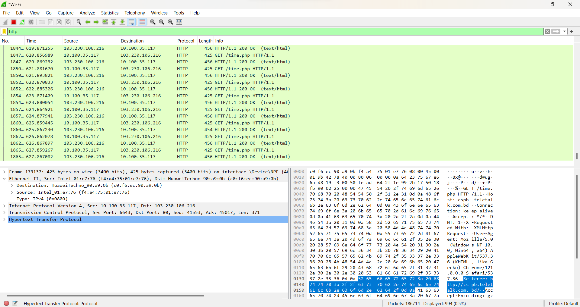

Ethernet are primarily used in **Data link layer**. Ethernet works by encapsulating data into frames at the Data Link Layer, using MAC addresses to specify the source and destination of the data, and transmitting these frames over the physical network medium, such as copper wires or fiber optics, for communication between devices within the same local area network (LAN).

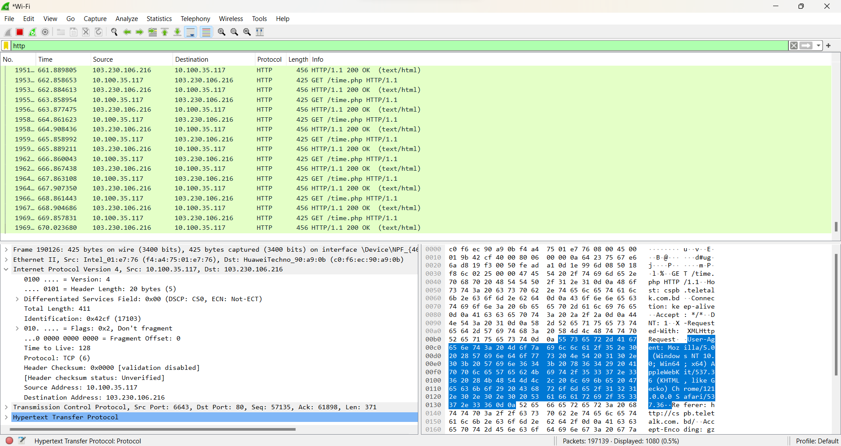

IP address used in **Network layer**. IP works by routing and forwarding data packets between devices on interconnected networks using logical addressing (IP addresses) to identify the source and destination of the packets.

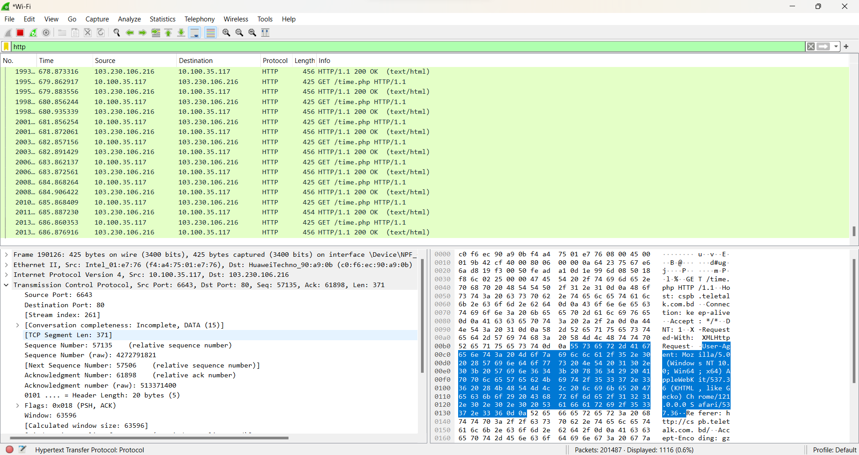

The Transmission Control Protocol (TCP) operates at the **Transport Layer**. TCP works by providing reliable, connection-oriented communication between devices by segmenting data into packets, establishing a connection, ensuring packet delivery, and managing flow control and error recovery mechanisms.

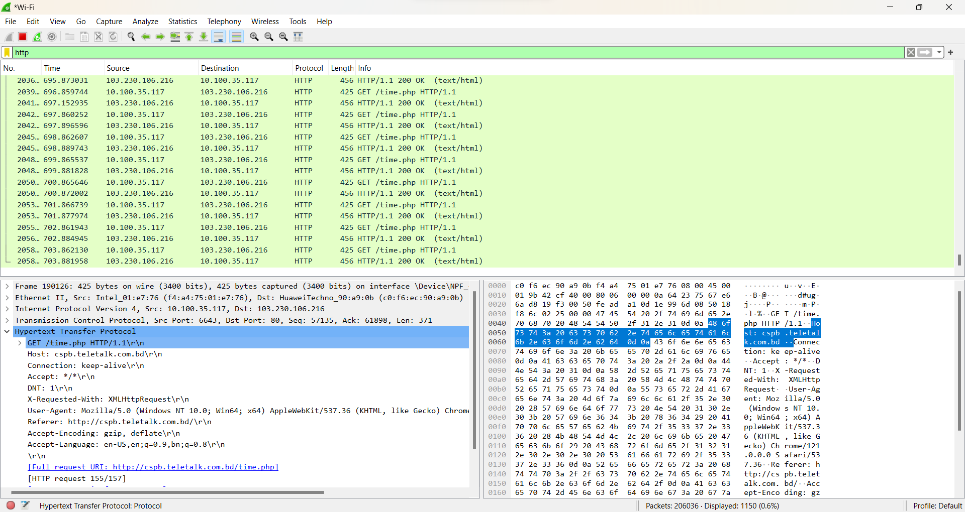

The Hypertext Transfer Protocol (HTTP) operates at the **Application Layer**. HTTP works by facilitating communication between web browsers and web servers, enabling the exchange of hypertext documents, such as web pages, through requests and responses using a client-server model.